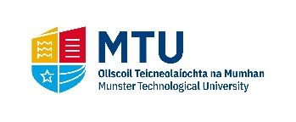
MTU Conferring Schedule of Ceremonies by Award

Date | Time | Department | Award
23rd May 2022 | 10.00am | Cork School of Music ( @ Cork School of Music) | Bachelor of Arts (Honours) in Popular Music
 |  |  | Bachelor of Arts (Honours) in Theatre and Drama Studies
 |  |  | Bachelor of Music (Honours)
 |  |  | Master of Arts in Music
 |  |  | Master of Science in Music and Technology
 |  |  | Master of Arts in Music and Technology
 | 2.30pm | Joint MTU/UCC Awards | MTU & NUI Bachelor of Science (Honours) in Architecture
 |  |  | MTU & NUI Bachelor of Science (Honours) in Industrial Physics
 |  |  | MTU & NUI Bachelor of Science (Honours) in Biomedical Science
 |  |  | MTU & NUI Master of Architecture
 |  |  | MTU & NUI Professional Master of Education (Art & Design)
 |  |  | Bachelor of Arts (Honours) in Visual Communications
 | 4.30pm | Department of Media Communications | Bachelor of Arts (Honours) in Creative Digital Media
 |  |  | Master of Arts in E-learning Design & Development
 |  |  | Master of Arts in Public Relations with New Media
 |  | Department of Arts in Health & Education | Master of Arts in Art Therapy
 |  | Department of Fine Art & Applied Art | Bachelor of Arts (Honours) in Contemporary Applied Art (Ceramics, Glass, Textiles)
 |  |  | Bachelor of Arts (Honours) in Fine Art

